ASSIGNMENT

Q1. Explore the search space diagram for the tic-tac toe game .Solve using minmax algorithm to find the optimal path where the max would win. Assumption: Selection of appropriate value of utility numbers and begin with the max player

.

#### ****tep 1: Represent the Current Board State****

The given image shows a **3x3 board** with X and O moves. Let's assume this configuration:

mathematica

CopyEdit

X | _ | _

X | O | _

O | X | O

Where:

* X (Max) needs to move next.
* _ represents empty spaces.

#### ****Step 2: Generate the Game Tree****

From this state, **X** has three possible moves. Each leads to a new board configuration. The tree expands further as O responds.

#### ****Step 3: Assign Utility Values****

* A win for X is assigned **+1**.
* A win for O is assigned **-1**.
* A draw is assigned **0**.

#### ****Step 4: Apply Minimax Algorithm****

1. **Max (X) plays first:** It places X in an empty position.
2. **Min (O) responds:** Tries to place O to minimize X's chances of winning.
3. **The tree expands until a terminal state (win, lose, or draw) is reached.**
4. **Backpropagate scores up the tree** and select the best move.

Q2. Each letter is one digit integer 0,1,2 to 9, each having a different value. What are the values of each of the letters? Solve to make your agent rationally think in terms of domains and variables as well.

SEND

+MORE

------------

MONEY

### Step 1: Analyze the structure

* **SEND** and **MORE** are four-digit numbers, and their sum is a five-digit number, **MONEY**.
* The first letter of the sum, **M**, must be 1 because the sum is a five-digit number (since **SEND + MORE** is at least 10000).

So, **M = 1**.

### Step 2: Deduce other constraints

* The **M** in **MONEY** is 1, so **MONEY** is in the range 10000–19999.
* Since **M = 1**, and the sum is a five-digit number, **SEND + MORE** must be between 10000 and 19999.

### Step 3: Use logical deductions

We can use constraints:

* **S** must be 8 or 9 because **SEND** and **MORE** together must be large enough to result in a five-digit number starting with 1.

Q3 . Solve the game tree using alpha-beta pruning algorithm. Evaluate the respective utility number at the root of the game tree.

. 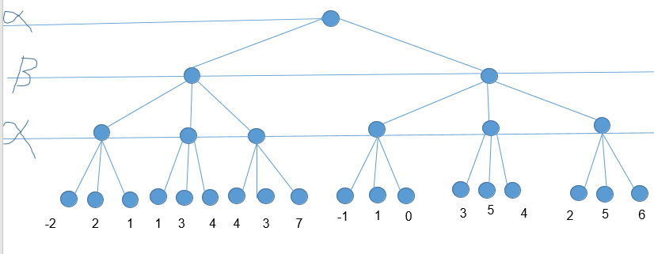

Q4. Given an undirected graph and a number m, determine if the graph can be coloured with at most 3colours such that no two adjacent vertices of the graph are colored with the same color. Here coloring of a graph means the assignment of colors to all vertices. (use backtrack)

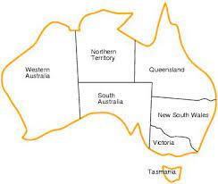

Q5. Solve the N-Queens problem using Genetic Algorithm.

The **N-Queens problem** is a classic combinatorial problem where the goal is to place **N queens** on an **N×N chessboard** such that no two queens threaten each other. This means no two queens can be in the same row, column, or diagonal.